Spectral coherence: GBPUSD and USDJPY
Method 21 / daily log returns / Welch magnitude-squared coherence / Alpari D1 full available history

Study setup
Logical pair: GBPUSD , USDJPY
Broker symbols: GBPUSD_i , USDJPY_i
Snapshot: 2026-11-03_majors_alpari_D1
Timeframe: D1
Matched return window: 1999-01-05 to 2026-11-02 (UTC bar dates)
Matched return count n: 7200
Dropped unfinished last bar dated 2026-11-03 UTC after a tick-volume check against the prior complete day.
Welch: fs=1.0, nperseg=256, noverlap=128, window=hann, detrend=constant
Headline: gamma^2 nearest f=1/5; also 1/21 and 1/63
Complete matched rows (Excel): GBPUSD-USDJPY_Spectral_D1.xlsx
Complete matched rows (HTML table): GBPUSD-USDJPY_Spectral_D1_data.html

Method carried forward
Magnitude-squared spectral coherence gamma^2(f) measures shared linear power between matched daily log returns of close, ln(close_t / close_t-1), at each frequency f (cycles per day). Quotes are not inverted. Welch settings are frozen: fs=1, nperseg=256, noverlap=128, window=hann, detrend=constant. Headline is gamma^2 at the frequency bin nearest f=1/5 (five-day cycle from the formula sheet). Also reported: gamma^2 nearest f=1/21 and f=1/63, mean gamma^2 over the frequency grid, and phase of the cross-spectrum at the 1/5 bin. Coherence is unsigned (0 to 1); phase carries timing. Same-sample Pearson r is a side check only. This is not causation and not a trading signal.

Results (headline)
gamma^2 near 1/5: 0.069672
bin f (1/5): 0.199219
phase at 1/5 (rad): 2.283568
gamma^2 near 1/21: 0.028496
gamma^2 near 1/63: 0.041409
mean gamma^2: 0.063201
Pearson r: -0.198556

Target-frequency summary
period | target_f | f_bin | gamma2 | phase_rad
5 | 0.2 | 0.19921875 | 0.06967175 | 2.2835678
21 | 0.04761905 | 0.046875 | 0.02849638 | -2.5458069
63 | 0.01587302 | 0.015625 | 0.04140909 | -2.351273

Conclusion
Headline gamma^2 near f=1/5 for GBPUSD and USDJPY: 0.0697 (bin f=0.199219, phase=2.2836 rad). At ~1/21: 0.0285; at ~1/63: 0.0414. Mean gamma^2 = 0.0632. Pearson r = -0.1986. This is frequency-domain linkage, not a trading signal.

Charts
Daily closes

Daily log returns

Spectral coherence gamma^2(f)
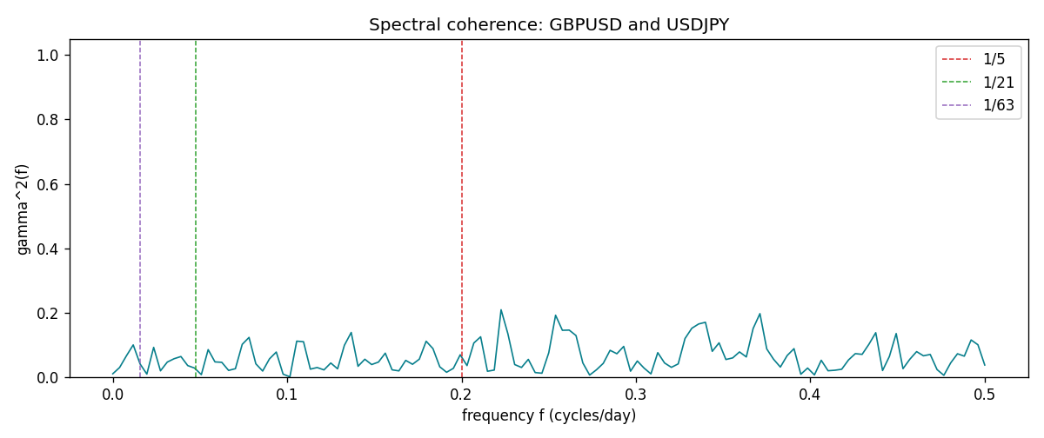

Data report
Matched rows and the coherence sheet are in the sibling Excel workbook named GBPUSD-USDJPY_Spectral_D1.xlsx. Embedding all rows as a Word table is impractical; this file holds column summaries and the first and last 15 matched rows.
Columns: time, GBPUSD_open, USDJPY_open, GBPUSD_high, USDJPY_high, GBPUSD_low, USDJPY_low, GBPUSD_close, USDJPY_close, GBPUSD_tick_volume, USDJPY_tick_volume, GBPUSD_spread, USDJPY_spread, GBPUSD_real_volume, USDJPY_real_volume, GBPUSD_log_return, USDJPY_log_return
Column summaries (matched calculation rows)
column | count | mean | std | min | 25% | 50% | 75% | max
GBPUSD_open | 7200 | 1.5159933 | 0.21821503 | 1.06854 | 1.3249725 | 1.51133 | 1.63163 | 2.1066
USDJPY_open | 7200 | 113.81122 | 19.205564 | 75.693 | 104.42925 | 110.991 | 120.69125 | 163.824
GBPUSD_high | 7200 | 1.5222906 | 0.21878569 | 1.08366 | 1.329785 | 1.518035 | 1.638315 | 2.1161
USDJPY_high | 7200 | 114.30876 | 19.267108 | 76.001 | 104.8815 | 111.4435 | 121.26 | 163.978
GBPUSD_low | 7200 | 1.5096683 | 0.2174426 | 1.03518 | 1.319445 | 1.50319 | 1.6243 | 2.0983
USDJPY_low | 7200 | 113.28793 | 19.133561 | 75.402 | 103.89 | 110.5305 | 120.17 | 163.628
GBPUSD_close | 7200 | 1.5160611 | 0.21817876 | 1.06879 | 1.3250775 | 1.511235 | 1.63193 | 2.1065
USDJPY_close | 7200 | 113.82409 | 19.220954 | 75.811 | 104.42 | 111.028 | 120.6855 | 163.851
GBPUSD_tick_volume | 7200 | 94838.03 | 153554.65 | 62 | 10001.75 | 52905.5 | 91812.25 | 1273370
USDJPY_tick_volume | 7200 | 106136.9 | 179308.31 | 149 | 9925 | 53095 | 92761 | 1803508
GBPUSD_spread | 7200 | 26.967917 | 19.192953 | 0 | 11 | 20 | 50 | 50
USDJPY_spread | 7200 | 20.325556 | 17.633971 | 0 | 6 | 11 | 30 | 50
GBPUSD_real_volume | 7200 | 3.5565837e+09 | 8.4444068e+10 | 0 | 0 | 0 | 0 | 2.4038164e+12
USDJPY_real_volume | 7200 | 3.470121e+10 | 1.6077679e+11 | 0 | 0 | 0 | 0 | 3.8834203e+12
GBPUSD_log_return | 7200 | -2.396e-05 | 0.00564572 | -0.08388241 | -0.0031301 | 3.232e-05 | 0.00317911 | 0.03112653
USDJPY_log_return | 7200 | 4.769e-05 | 0.00620489 | -0.03908203 | -0.00320192 | 0.00011421 | 0.00340709 | 0.05184024
First 15 matched rows (selected columns)
time | GBPUSD_log_return | USDJPY_log_return
1999-01-05 | -0.0028966287 | -0.00017868311
1999-01-06 | -0.00060452184 | 0.0075660159
1999-01-07 | -0.002118709 | -0.012851583
1999-01-08 | -0.0058954193 | -0.0047719894
1999-01-11 | -0.0056851331 | -0.016195423
1999-01-12 | 0.0022657001 | 0.032310364
1999-01-13 | 0.0091330396 | 0.0081373171
1999-01-14 | 0.0019376331 | 0
1999-01-15 | -0.0017558204 | 0.0055343401
1999-01-18 | 0.0012112405 | 8.7600193e-05
1999-01-19 | 0.0018745281 | -0.0056219403
1999-01-20 | -0.0049053846 | -0.0053879917
1999-01-21 | 0.0031518998 | 0.0084664056
1999-01-22 | 0.0024781662 | 0.0060412564
1999-01-25 | 0.0012066366 | -0.0073594164
Last 15 matched rows (selected columns)
time | GBPUSD_log_return | USDJPY_log_return
2026-10-13 | 0.0036434319 | -0.0018932826
2026-10-14 | -0.0049164679 | 7.5800166e-05
2026-10-15 | 0.0065976411 | -0.0018524319
2026-10-16 | 0.0037592051 | -0.00037976126
2026-10-19 | -0.0017500314 | 0.0034946841
2026-10-20 | 0.0055923442 | -0.0022546642
2026-10-21 | 0.0012476328 | -0.00032883504
2026-10-22 | 0.00022396082 | -0.0085942669
2026-10-23 | -0.0021146949 | 0.00035080446
2026-10-26 | -0.0024340661 | 0.0041238746
2026-10-27 | -0.0023648393 | 0.0027651658
2026-10-28 | 0.0015771808 | -0.00095679538
2026-10-29 | 0.0035881935 | -0.00038043789
2026-10-30 | 0.0013450605 | -0.0010596481
2026-11-02 | 0.0010971256 | 0.0026438521
First 15 frequency bins
f | gamma2 | phase_rad | period_days
0 | 0.01073076 | 3.1415927 | inf
0.00390625 | 0.03014293 | -2.514772 | 256
0.0078125 | 0.06642712 | -2.7566525 | 128
0.01171875 | 0.10033914 | -2.9908484 | 85.333333
0.015625 | 0.04140909 | -2.351273 | 64
0.01953125 | 0.00972921 | -2.3559694 | 51.2
0.0234375 | 0.09269881 | 2.9393511 | 42.666667
0.02734375 | 0.01986651 | 2.9165553 | 36.571429
0.03125 | 0.04699899 | 2.9726777 | 32
0.03515625 | 0.05746015 | -2.8627792 | 28.444444
0.0390625 | 0.06425158 | -2.784701 | 25.6
0.04296875 | 0.03613619 | -2.7579847 | 23.272727
0.046875 | 0.02849638 | -2.5458069 | 21.333333
0.05078125 | 0.00802836 | 2.4294595 | 19.692308
0.0546875 | 0.0857294 | 2.9721783 | 18.285714

